|  |
| --- |
| detail of persons hands with scissors, markers, workingPROJECT REPORT: Predictive Analysis of Customer Spending Power (Customer Segmentation) |

|  |  |  |
| --- | --- | --- |
| Team 5 |  |  |
|  |  |  |

TABLE OF CONTENTS

Predictive Analysis of Customer Spending Power (Customer Segmentation) 3

Strategic Highlights / Business Case 3

Objective 3

Data Collection 3

Data Preparation 4

Data Exploration & Visualization 4

Age Grouping 9

Model Building 10

I. OLS with Forward Selection 10

Results 11

II. Bayesian Linear Regression with PyMC3 12

Conclusions 15

FINANCIAL STATEMENTS 16

Statement of Financial Position 16

Statement of Comprehensive Income (Profits and Losses) 16

Statement of Changes in Equity 16

Statement of Cash Flows 16

References 17

# Predictive Analysis of Customer Spending Power (Customer Segmentation)

## Strategic Highlights / Business Case

*To predict the spending power of the target customers by understanding the trends of spending score.*

**Customer segmentation** is the practice of dividing a customer base into groups of individuals that are similar in specific ways relevant to marketing, such as age, gender, interests and spending habits.

**Customer Segmentation for Target Marketing:** Companies employing customer segmentation operate under the fact that every customer is different and that their marketing efforts would be better served if they target specific, smaller groups with messages that those consumers would find relevant and lead them to buy something. Companies also hope to gain a deeper understanding of their customers' preferences and needs with the idea of discovering what each segment finds most valuable to more accurately tailor marketing materials toward that segment.

## Objective

1. Analyze the dataset to understand the dependency of spending score on available factors: Age, Annual Income, and Gender.
2. Create 2 models to predict spending score of the target customers (in the available dataset).
3. Comparative analysis of the two models (Ordinary Least Squares (OLS) with Forward Selection, and Bayesian Linear Regression with PyMC3)

## Data Collection

Through membership cards, some basic data about customers like Customer ID, age, gender, annual income and spending score are gathered for a shopping mall’s customers.

(Data in our case is simulated)

***Spending score is a score assigned to the customer based on certain defined parameters like customer behavior and purchasing data.***

|  |
| --- |
| ***Problem Statement: Understand the likelihood of buying or predicting the customers who are more likely to converge [Target Customers] so that marketing strategies could be designed to cater to those target customers.*** |

## Data Preparation

**Dataset Details:**

* **CustomerId:** Customer's unique ID
* **Gender:** Customer's gender
* **Age:** Customer's age
* **Annual Income:** Customer's annual income
* **Spending Score:** A score, out of 100, to rate customer's behavior and money spent by the customer.

|  |  |
| --- | --- |
| Independent Variables | Dependent Variable |
| Age, Annual Income, Gender | Spending Score |

Figure : Snippet of Dataset

## Data Exploration & Visualization

We drop CustomerID as it is just a identifier unique id and will not impact spending score.

We also drop Gender as..

Basic statistical details of the dataset:

Figure : Basic Statistical Details of Dataset

**Histogram Plots:**

From the histogram plots we see that the dependent variables and independent variables are normally distributed. Therefore, we can use OLS regression analysis on this data.

Figure : Histogram Plots

**Boxplot & Swarmplots**

Figure : Boxplots and Swarmplots

**Summary observation on original dataset:**

We see that Age and Annual Income are not colinear. The correlation between the spending score and age and, spending score and annual income is low. Thus it would be appropriate to conduct regression analysis on our dataset.

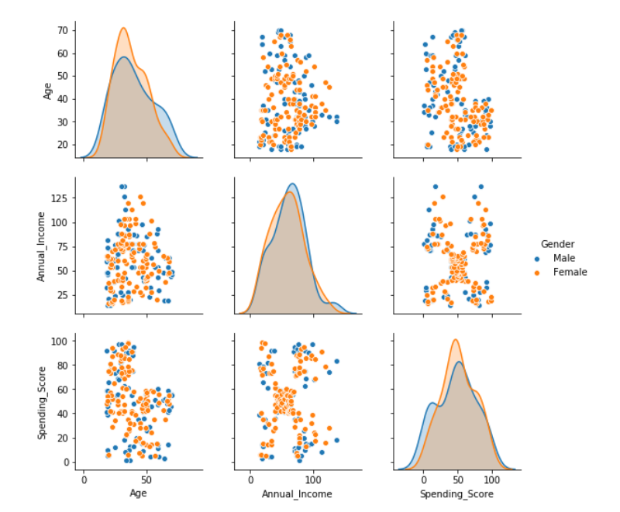

Figure : Pairplots on the Original Dataset

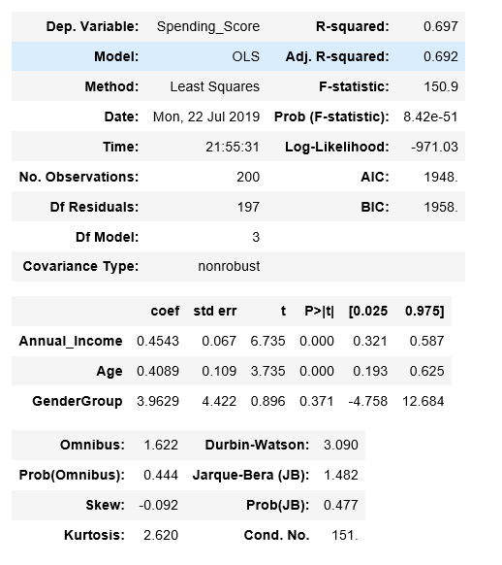

Figure : OLS Regression Results on Original Dataset

We see a low R-squared value of 0.697. p-value for GenderGroup is high (>0.05) showing that it is not a significant factor for the change in spending score. We can drop GenderGroup from our model.

1. No clear linear relationship between the spending _score and independent variables like annual_income and age.

2. A single linear multivariate regression that models the relationship between the dependent variable and the independent variables returns a low R-squared at around 69.7%

3. An intercept should be excluded as no annual income suggests no spending power/score.

## Age Grouping

We will divide the data into the age groups and try to run regression analysis for each age group. We do this to find out which age group has more significant effect on the spending score.

We split age into **6 Age Groups**: Below 25, 26 – 35, 36 – 45, 46 – 55, 56 – 65, Above 65.

Figure : Dataset snippet after age grouping

# Model Building

## OLS with Forward Selection

**Forward Selection**: Forward selection is a type of stepwise regression which begins with an empty model and adds in variables one by one. In each forward step, we add the one variable that gives the single best improvement to your model.

We begin with only an intercept. We test the various variables that may be relevant, and the ‘best’ variable—where “best” is determined by a pre-determined criteria—is added to the model.

As the model continues to improve (per that same criteria) we continue the process, adding in one variable at a time and testing at each step. Once the model no longer improves with adding more variables, we stop the process.

As descried above we applied a forward elimination on the linear multivariate regressions on each age group to select the combinations of independent variables that yield highest R-squared.

# Results

**Results of regression analysis (OLS with Forward Selection):**

|  |  |  |
| --- | --- | --- |
| Age Group | Regression Equation | R-squared |
| Below 25 | Spending_Score = 4.0296 * Age - 0.6769 * Annual_Income  (T-value:0) (T-value:0) | 89% |
| 26 - 35 | Spending_Score = 1.6762 * Age + 0.1718 * Annual_Income  (T-value:0) (T-value:0.11) | 86% |
| 36 - 45 | Spending_Score = 0.5828 * Age + 0.2917 * Annual_Income  (T-value:0.13) (T-value:0.15) | 70% |
| 46 - 55 | Spending_Score = 0.7401 * Age  (T-value:0) | 83% |
| 56 - 65 | Spending_Score = 0.5358 * Age  (T-value:0) | 71% |
| Above 66 | Spending_Score = 0.2173 * Age + 0.6344 * Annual_Income  (T-value:0.01) (T-value:0.19) | 97% |

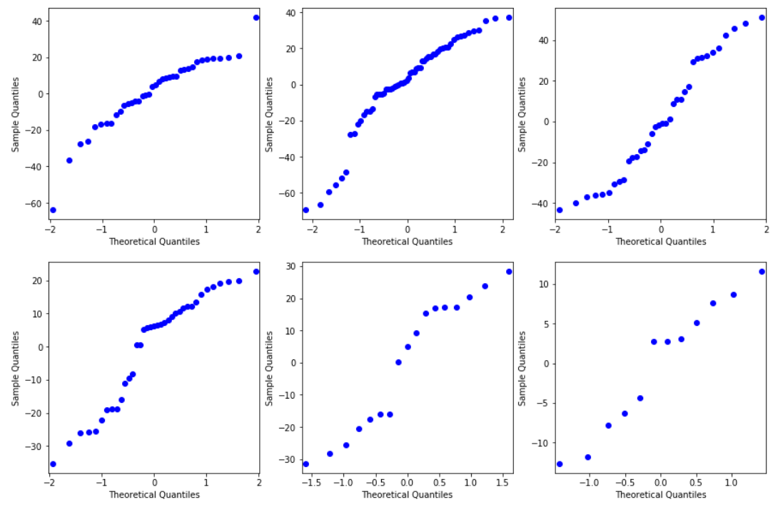

Figure : qqplot of Residuals for the 6 Age Groups (OLS)

From the above we can see that the residuals are along the diagonal, which shows normal distribution of residuals. The residuals are nearly normally distributed & centered on 0.

**Observations:**

1. R-squared for regression on each age group improve significantly.

2. the residuals are normally distributed.

3. Some independent variables have T-value higher than 5%, suggesting that they are not a significant determinant for the spending_score. However, we argue that including those variables give us the best predicting power as combing them with other variables yield highest R-squared.

4. Annual_Income is negatively correlated with the spending_score for customers below 25.

5. Annual_Income does not seem to have any relationship with the spending_score for customers between 46 years old to 65 year old.

6. there are not many data for the age group above 56 (56-65 and above 66). Therefore, the regression results in these two groups could change significantly with more data collection.

## II. Bayesian Linear Regression with PyMC3

Now, we are going to introduce regression modelling in the Bayesian framework and carry out inference using the PyMC3 MCMC library.

In a Bayesian framework, linear regression is stated in a probabilistic manner. That is, we reformulate the above linear regression model to use probability distributions. In the Bayesian formulation we receive an entire probability distribution that characterises our uncertainty on the different β coefficients. The immediate benefit of this is that after taking into account any data we can quantify our uncertainty in the β parameters via the variance of this posterior distribution. A larger variance indicates more uncertainty.

**Plotting the heatmap to find out correlation between different parameters:**

Figure : Bayesian Regression - Heatmap

# Conclusions

Since our dataset is simulated and is not …

However, doing a 2 model comparison,

For example, this is the List Bullet style.

Here is another sentence formatted in List Bullet style.

You can find easy-to-use tools on the Insert tab, such as to add a hyperlink, insert a comment, or add automatic page numbering.

|  |
| --- |
|  |

View and edit this document in Word on your computer, tablet, or phone. You can edit text; easily insert content such as pictures, shapes, and tables; and seamlessly save the document to the cloud from Word on your Windows, Mac, Android, or iOS device.

# FINANCIAL STATEMENTS

## Statement of Financial Position

* Liabilities
* Statement of Financial Position
* Ownership Equity

## Statement of Comprehensive Income (Profits and Losses)

* Income
* Expenses
* Profits

## Statement of Changes in Equity

Well, it wouldn’t be an annual report without a lot of numbers, right? This section is the place for all those financial tables.

To get started with a table that looks just like the sample here, on the Insert tab, tap Table.

|  |  |  |  |
| --- | --- | --- | --- |
| DESCRIPTION | REVENUE | EXPENSES | EARNINGS |
|  |  |  |  |
|  |  |  |  |
|  |  |  |  |
|  |  |  |  |
|  |  |  |  |

## Statement of Cash Flows

* Operating
* Investing
* Financing

# References

* <https://searchcustomerexperience.techtarget.com/definition/customer-segmentation>